<Zelle>
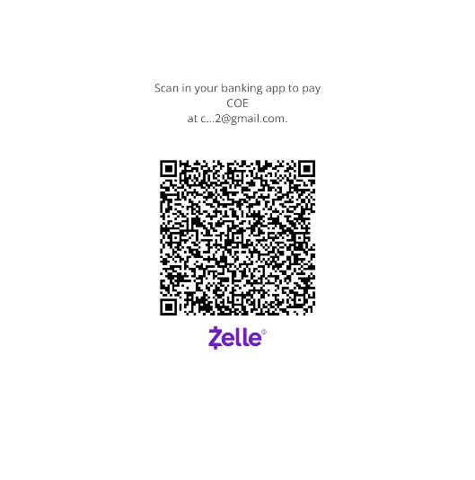
<Venmo>
https://venmo.com/u/Coe-Rutledge
<PayPal>
https://paypal.me/CoeRutledge?country.x=US&locale.x=en_US

