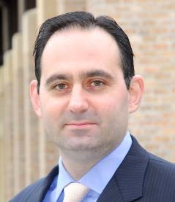

David Feygin, PhD, MBA

As Vice President of Health IT Integration and Strategic Innovation, David leads BD’s enterprise-wide health information technology capability development efforts to ensure commercial success and develops actionable strategies that improve patient outcomes, drive health system efficiency and enable BD’s growth through the application of information technology. Previously, As Vice President of Corporate Strategic Innovation for Becton Dickinson (BD), David was responsible for integrating company-wide activities focused on the identification of new market opportunities outside of existing core areas, the development of high-impact growth concepts that fall outside of, or cut across, existing business units and incubation of non-core offerings.

David is Chair of the Executive Council for The Center for Patient Safety Research and Practice, a thought leader in information-enabled healthcare safety with a primary focus on medication error and patient safety research. David serves as a board member and co-Chair of the Digital Health Committee for the Life Science Angels, the #1 ranked angel investor group in the US and for Health XL, a cross-industry consortia devoted to care transformation. As a strategic advisor to several population health management companies and his work for Digital Health accelerators and incubator, David strives to help entrepreneurs and companies develop profitable businesses that profoundly improve care quality and efficiency.

As World-Wide Director of Strategic Innovation for the BD - Medical Surgical Systems (MSS) business unit, David developed and led the MSS Strategic Innovation Group responsible for identifying, developing and validating opportunities and overall growth strategies. David has driven global strategy development efforts and business development activities that enabled growth through innovation; one of which resulted in a $12B acquisition. The Strategic Innovation Group is responsible for strategic marketing, market analytics, opportunity sensing, sourcing and evaluation, health economics analysis, fundamental business analytics, advanced customer research and driving innovation initiatives from market, clinical, technical and policy perspectives.

David received a Ph.D. in Mechanical Engineering from U.C. Berkeley for his work in virtual environments and medical simulation. He spent four years at medical simulator startups leading the development, commercialization and launch of state-of-the-art simulators including the Virtual I.V.TM product line. Prior to joining BD, David received an M.B.A. from the Harvard Business School.

